Sydney Contemporary

11. – 15.09.19

Dominik Mersch Gallery, Booth F03

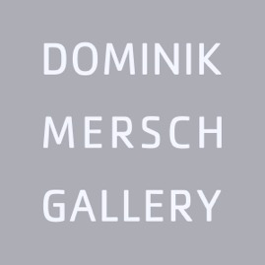

ANDREW ROGERS
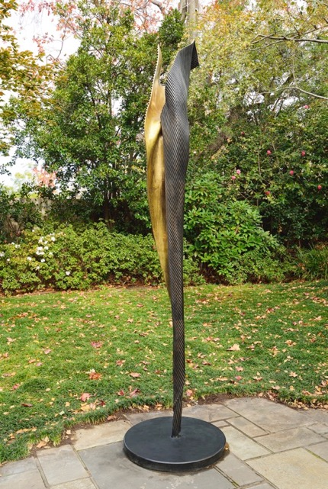
Andrew Rogers, ‘I Am I’, 2016, bronze, 240 x 42 x 35 cm, edition of 12 + 1AP

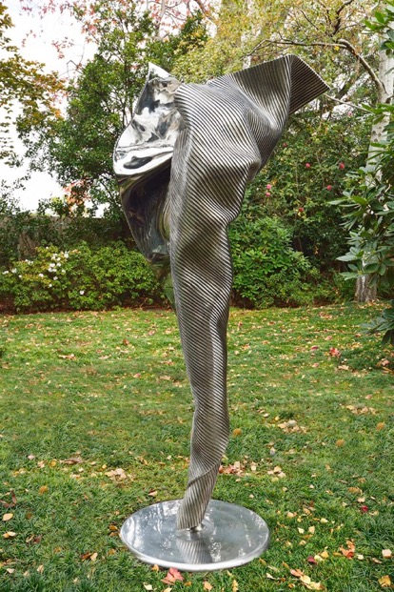

Andrew Rogers, ‘I Am’, 2015, stainless steel, 160 x 70 x 52 cm, edition of 12 + 1AP
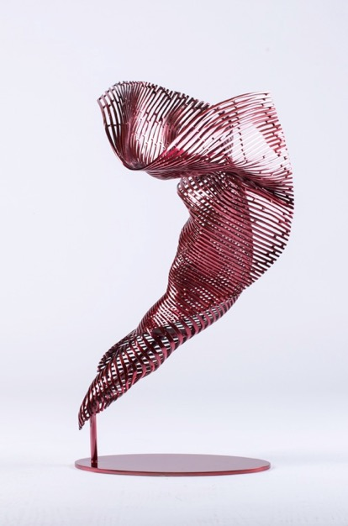
Andrew Rogers, ‘I Am-Dancer’, stainless steel, red polychrome, 69 x 38 x 39 cm,
edition of 12 + 1AP

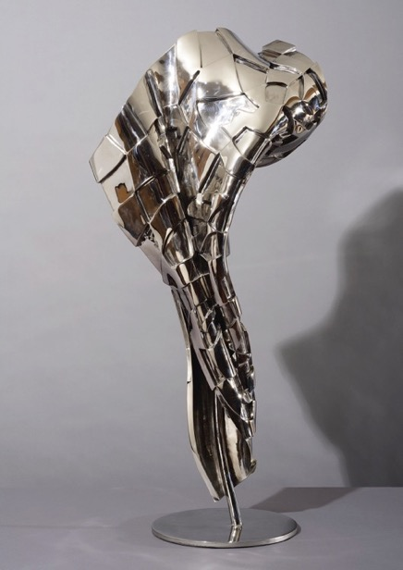

Andrew Rogers, ‘Tessera 3’, 2017, stainless steel, 107 x 46 x 27 cm, edition of 12 + 1AP

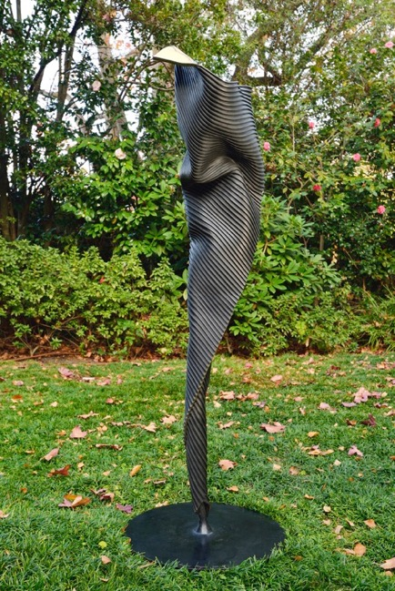

Andrew Rogers, ‘I Am II’, 2016, bronze, 135 x 36 x 28 cm, edition of 12 + 1AP

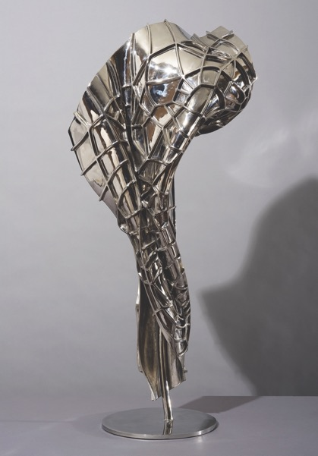

Andrew Rogers, ‘Tessera 1’, 2017, stainless steel, 107 x 46 x 27 cm, edition 1 of 12 + 1AP

Andrew Rogers, ‘Tessera 2’, 2017, stainless steel, 107 x 46 x 27 cm, edition 1 of 12 + 1AP

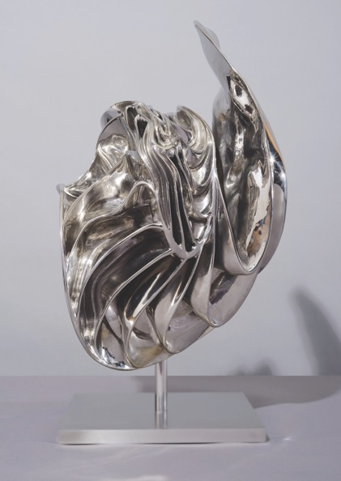

Andrew Rogers, ‘Molten Concept 19’, 2012, stainless steel, 67 x 50 x 44 cm, edition 1 of 7 + 1AP

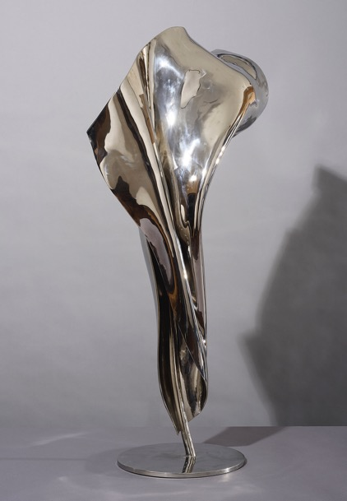

Andrew Rogers, ‘Tessera 0’, 2017, stainless steel, 107 x 46 x 27 cm, edition 1 of 12 + 1AP

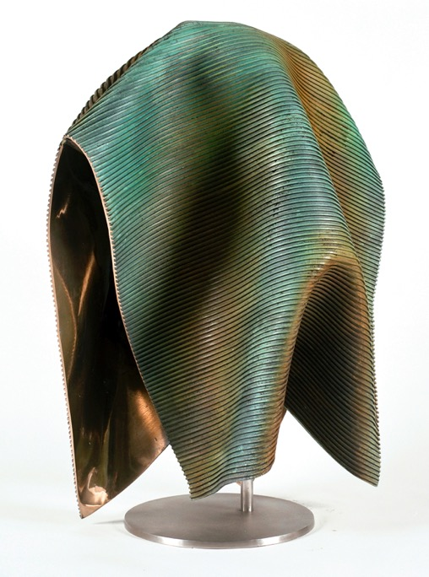

Andrew Rogers, ‘Folded’, 2003, bronze, 106 x 74 x 50 cm, edition of 12 + 1AP

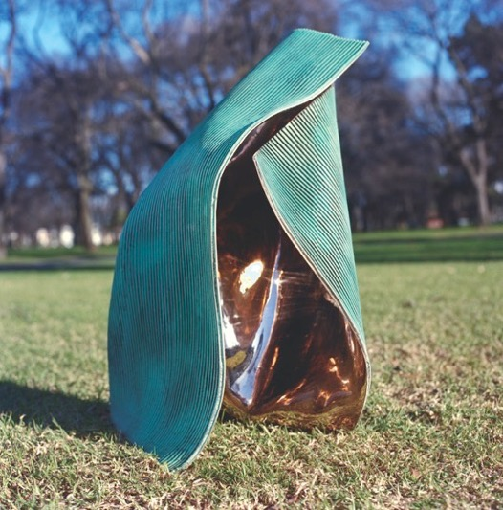

Andrew Rogers, ‘Folded 3’, 2003, bronze, 77 x 55 x 56 cm, edition of 12 + 1AP

CLEMENS KRAUSS

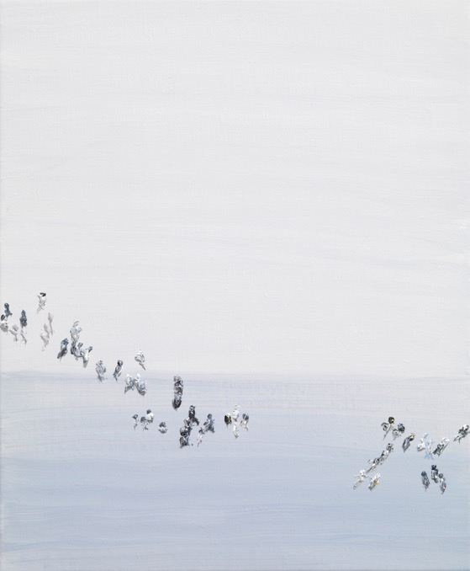

Clemens Krauss, ‘Single Files, 2018, oil on canvas, 60 x 50 cm
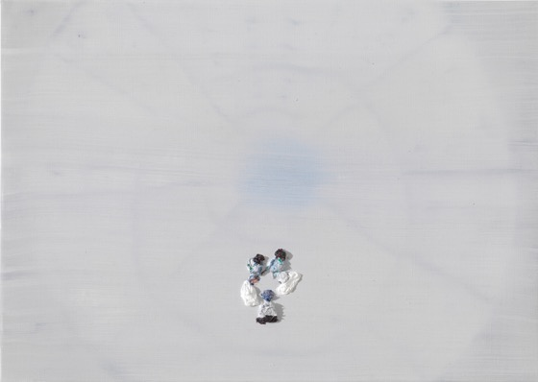

Clemens Krauss, ‘Erratisch’, 2018, oil on canvas, 50 x 70 cm

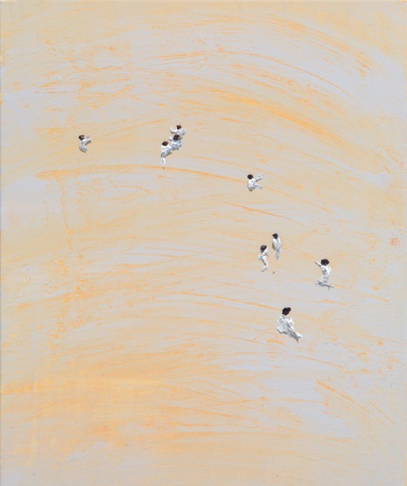

Clemens Krauss, ‘Zellen / Cells’, 2019, oil on canvas, 60 x 50 cm

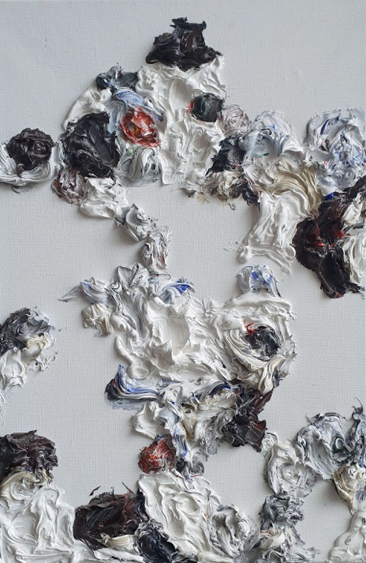

Clemens Krauss, U.T, 2019, oil on canvas, 60 x 40 cm

DANI MARTI
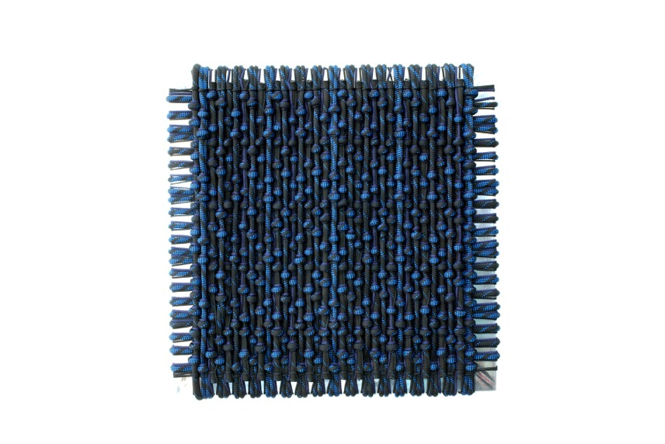
Dani Marti, 'Songs of Surrender', 2019, customised polyester, and polished aluminium,
60 x 60 x 5 cm

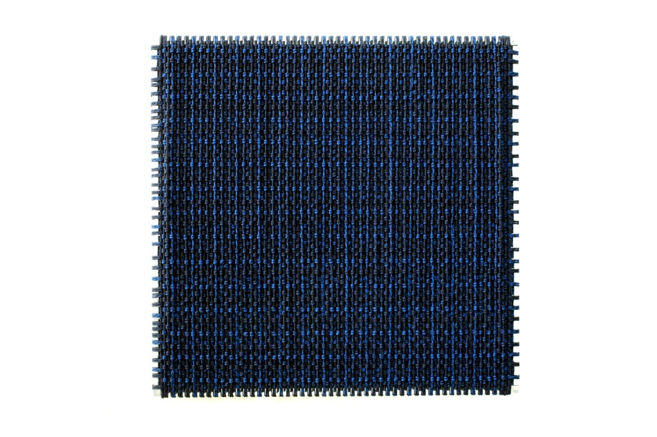
Dani Marti, ‘Songs of Surrender’, 2019, customised polyester, and polished aluminium,
177 x 177 x 5 cm
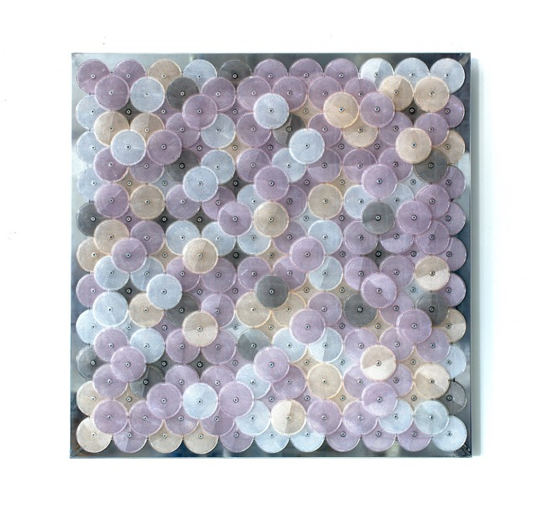
Dani Marti, ‘Dust (purple)’, 2019, customised corner reflectors, polished aluminium, 97 x 97 cm

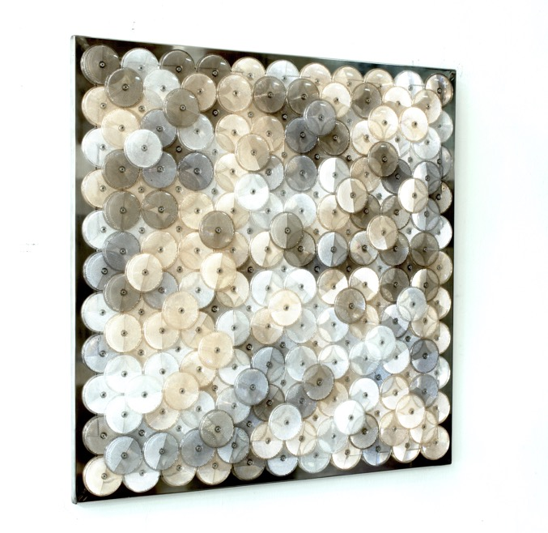

Dani Marti, ‘Dust (peach)’, 2019, customised corner reflectors, polished aluminium, 97 x 97 cm

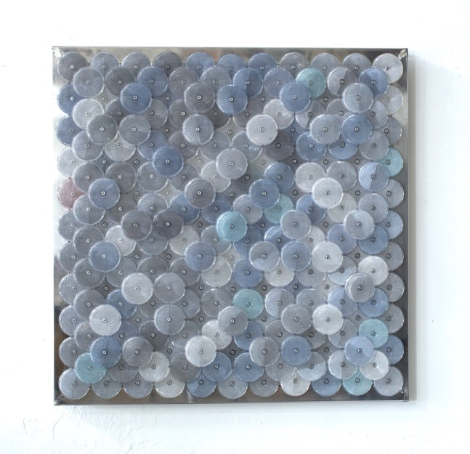
Dani Marti, ‘Dust (grey)’, 2019, customised corner reflectors, polished aluminium, 97 x 97 cm

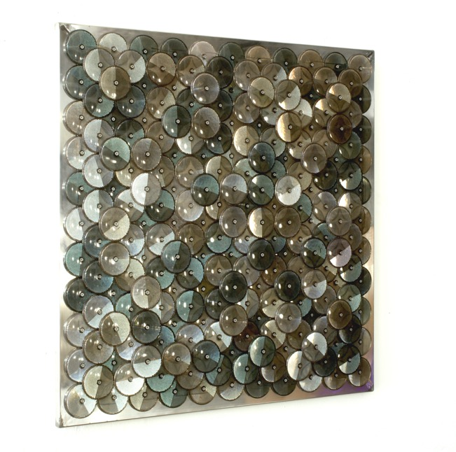
Dani Marti, ‘Dust (dark stone)’, 2019, customised corner reflectors, polished aluminium,
97 x 97 cm

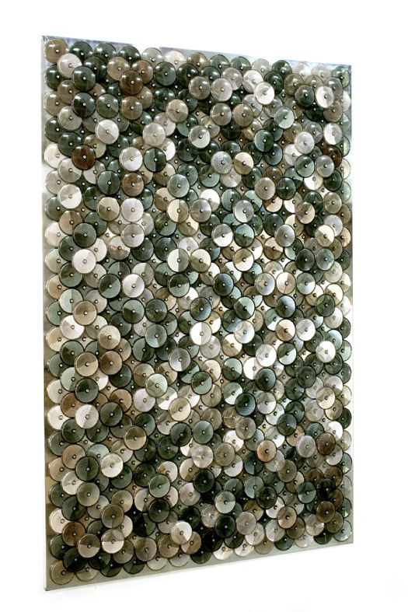
Dani Marti, ‘Dust (stone)’, 2019, customised corner reflectors, polished aluminium, 180 x 120 cm

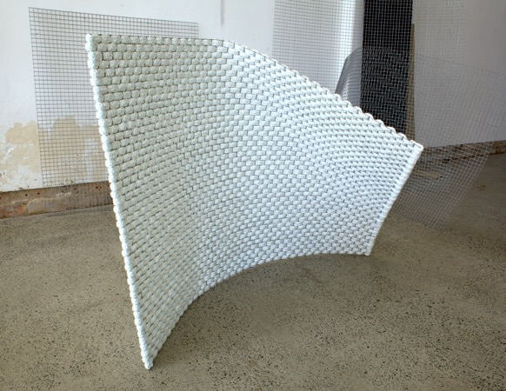

Fold, 2019, Polypropylene and steel, 160 x 110 x 120cm

ELGER ESSER

Elger Esser, ‘Gennes II’, 2017, Direktprint, Kupferplatte versilbert (silver copperplate), schellack, 27 x 34 x 4 cm, edition of 3 + 1AP

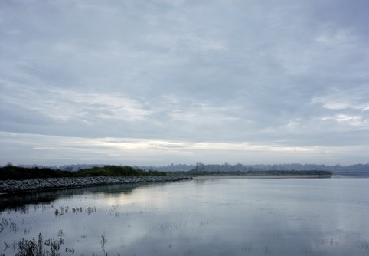

Elger Esser, ‘Orne II’, 2017, Direktprint, Kupferplatte versilbert (silver copperplate), schellack, 27 x 34 x 4 cm, edition of 3 + 1AP

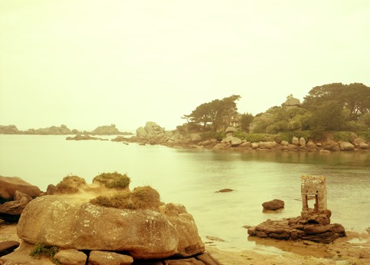

Elger Esser, ‘Saint Guirec’, 2017, Direktprint, Kupferplatte versilbert (silver copperplate), schellack, 27 x 34 x 4 cm, edition of 3 + 1AP

JANET LAURENCE
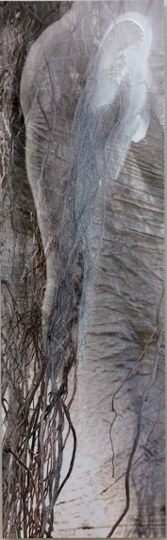

Janet Laurence, ‘Seeping Out, After the Theatre of Trees’ (1), 2019, dye sublimation archival print on Chromaluxe aluminium with paint and pigments, 100 x 30 cm, unique

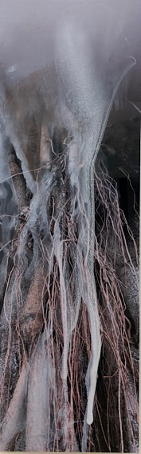

Janet Laurence, ‘Seeping Out, After the Theatre of Trees’ (2), 2019, dye sublimation archival print on Chromaluxe aluminium with paint and pigments, 100 x 30 cm, unique

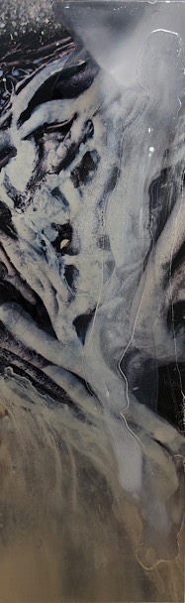

Janet Laurence, ‘Seeping Out, After the Theatre of Trees’ (3), 2019, dye sublimation archival print on Chromaluxe aluminium with paint and pigments, 100 x 30 cm, unique

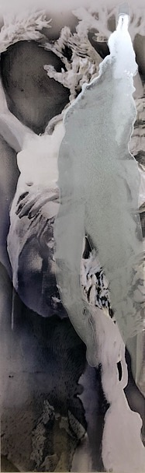

Janet Laurence, ‘Seeping Out, After the Theatre of Trees’ (4), 2019, dye sublimation archival print on Chromaluxe aluminium with paint and pigments, 100 x 30 cm, unique

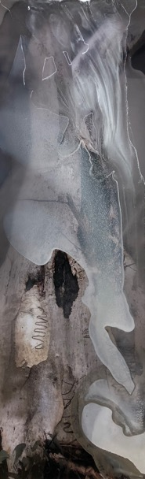

Janet Laurence, ‘Seeping Out, After the Theatre of Trees’ (5), 2019, dye sublimation archival print on Chromaluxe aluminium with paint and pigments, 100 x 30 cm, unique

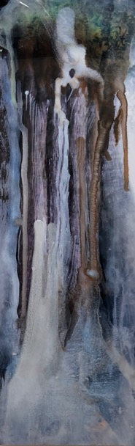

Janet Laurence, ‘Seeping Out, After the Theatre of Trees’ (6), 2019, dye sublimation archival print on Chromaluxe aluminium with paint and pigments, 100 x 30 cm, unique

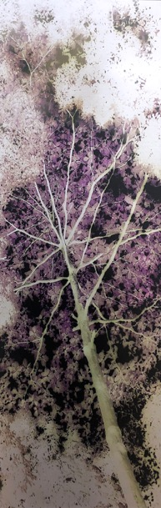

Janet Laurence, ‘Seeping Out, After the Theatre of Trees’ (7), 2019, dye sublimation archival print on Chromaluxe aluminium, 100 x 30 cm, edition of 3 + 1AP
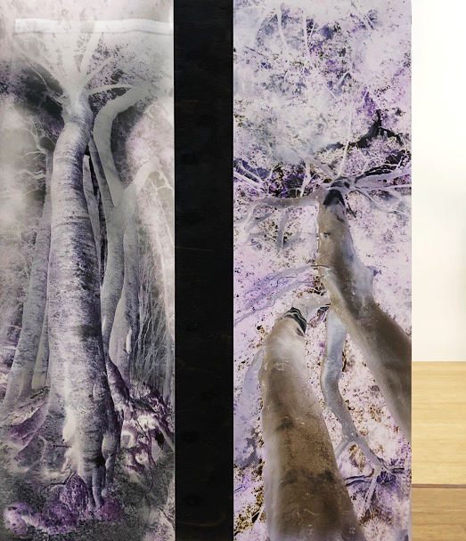

Janet Laurence, ‘Seeping Out, After the Theatre of Trees’ (diptych), 2019, dye sublimation archival print on Chromaluxe aluminium, wood, mirror, 100 x 73 cm overall, edition of 3 + 1AP

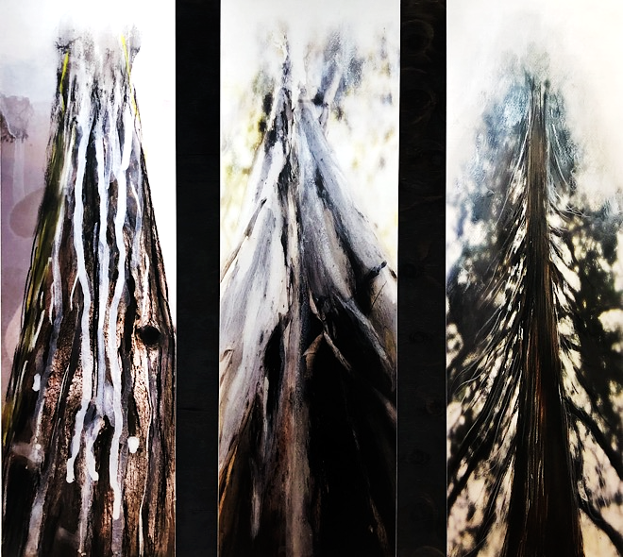
Janet Laurence, ‘Seeping Out, After the Theatre of Trees’ (triptych), 2019, dye sublimation archival print on Chromaluxe aluminium with paint and pigments, wood, triptych, 100 x 115 cm overall, unique

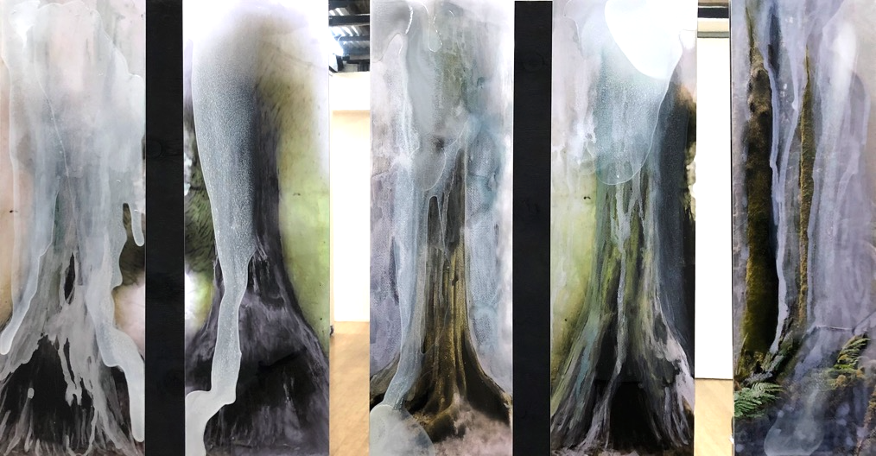
Janet Laurence, ‘Seeping Out, After the Theatre of Trees’ (five panel), 2019, dye sublimation archival print on Chromaluxe aluminium with paint and pigments, wood, mirror, five panels,
100 x 195 cm overall, unique

LOTTIE CONSALVO

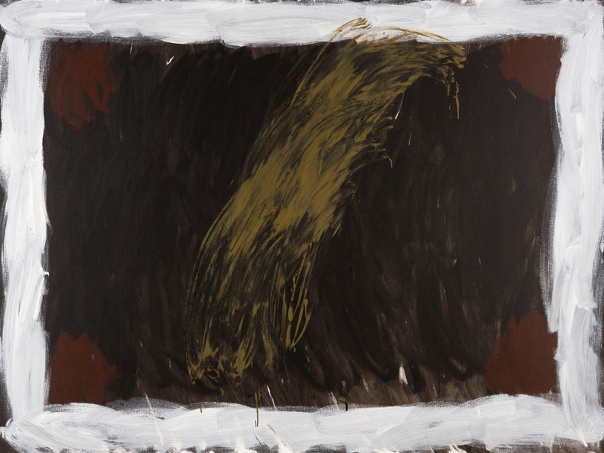

Lottie Consalvo, ‘It Rained With No Water’, 2019, acrylic on canvas, 180 x 240 cm

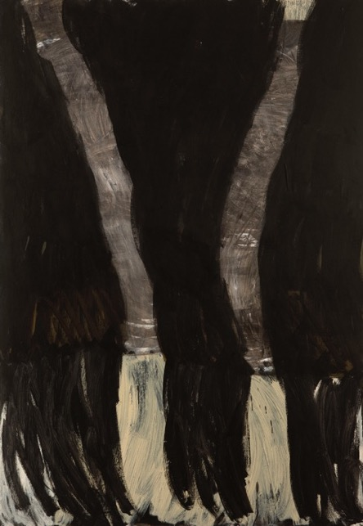

Lottie Consalvo, ‘An Anthem For Dreams’, 2019, acrylic on canvas, 198 x 137 cm

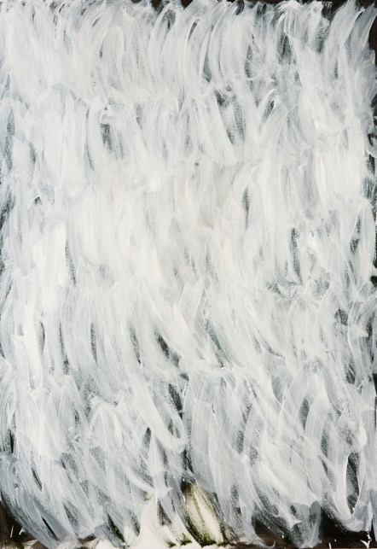

Lottie Consalvo, ‘An Anthem For The Sea’, 2019, acrylic on canvas, 198 x 137 cm

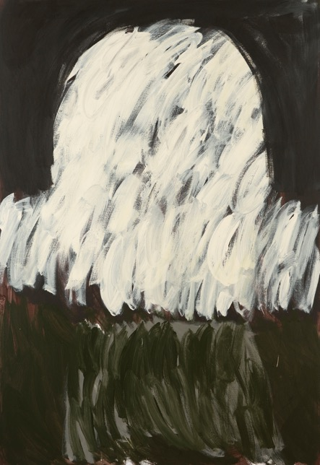
Lottie Consalvo, ‘Insurmountable’, 2019, acrylic on canvas, 198 x 137 cm

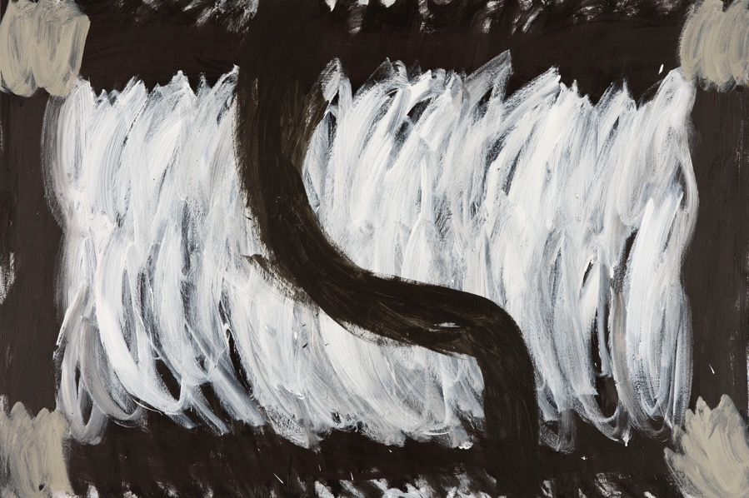
Lottie Consalvo, ‘The Sea Flooded The Sky’, 2019, acrylic on canvas, 122 x 183 cm

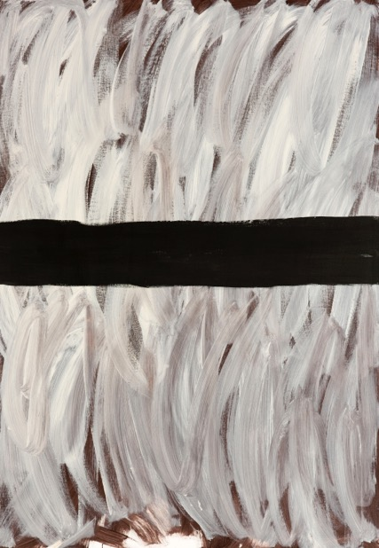

Lottie Consalvo, ‘In Retrospect’, 2019, acrylic on canvas, 153 x 107 cm

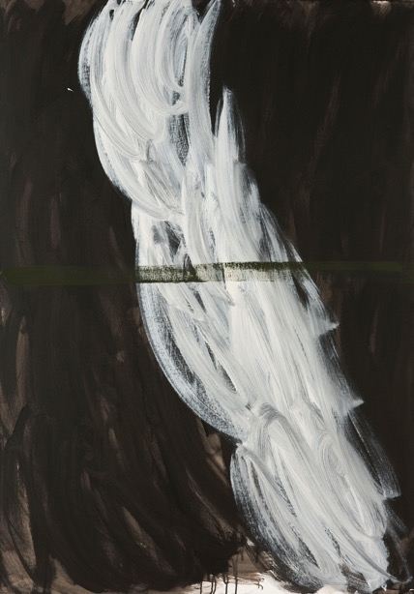

Lottie Consalvo, ‘I Saw You From The Sea’, 2019, acrylic on canvas,153 x 107 cm

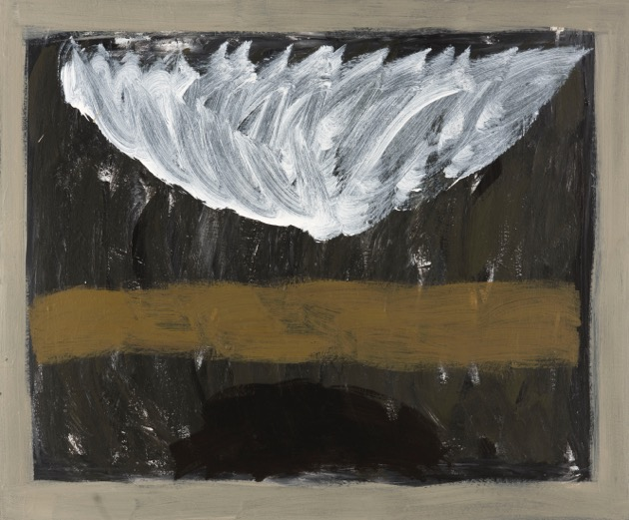

Lottie Consalvo, ‘Anchorless’, 2019, acrylic on board, 100 x 120 cm

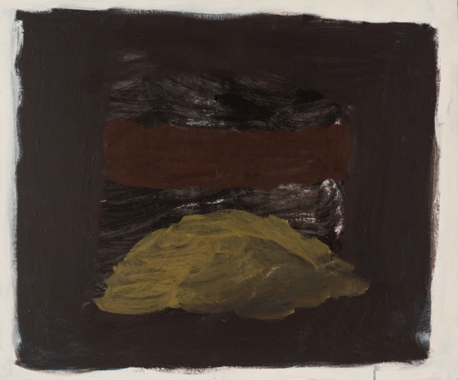
Lottie Consalvo, ‘Moving Towards’, 2019, acrylic on board, 100 x120 cm

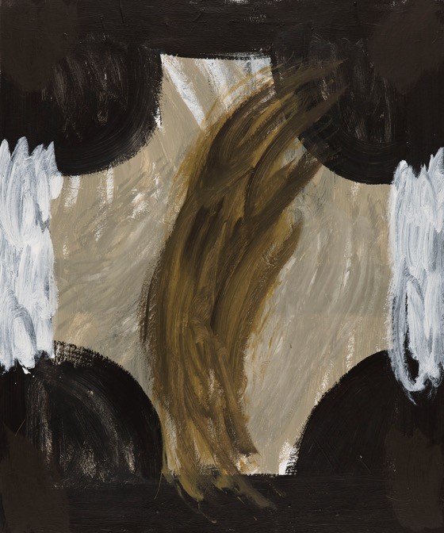

Lottie Consalvo, ‘A Deep Song In The Distance, 2019, acrylic on board, 100 x120 cm

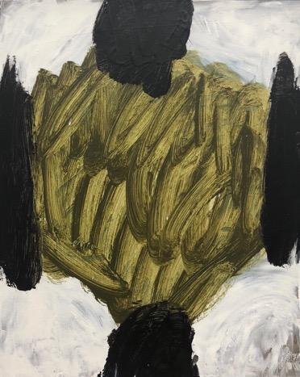
Lottie Consalvo, ‘Anthem 12’, 2019, acrylic on board, 40 x 50 cm

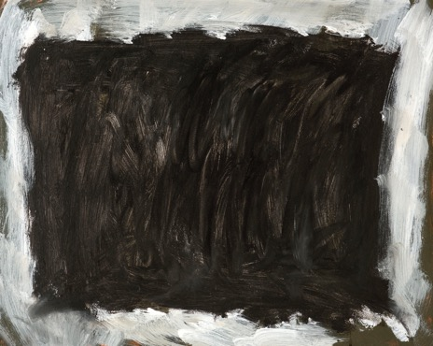

Lottie Consalvo, ‘Anthem 8’, 2019, acrylic on board, 40 x 50 cm

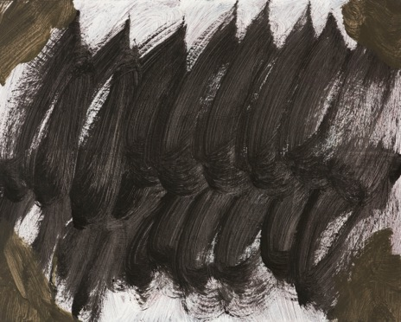

Lottie Consalvo, ‘Anthem 3’, 2019, acrylic on board, 40 x 50 cm

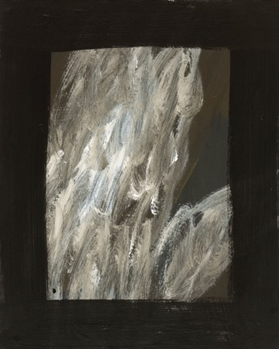

Lottie Consalvo, ‘Anthem 9’, 2019, acrylic on board, 50 x 40 cm

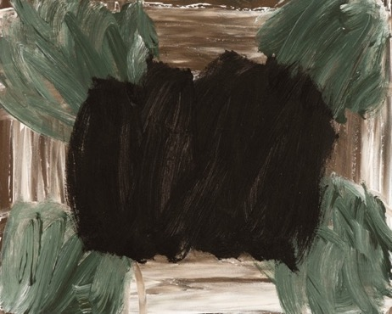
Lottie Consalvo, ‘Anthem 4’, 2019, acrylic on board, 40 x 50 cm

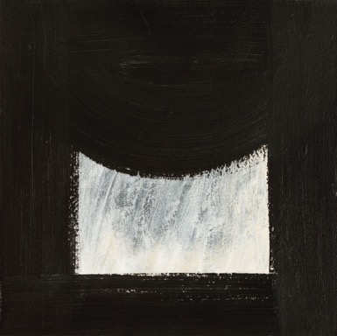

Lottie Consalvo, ‘From Here 1’, 2019, acrylic on board, 30 x 30 cm

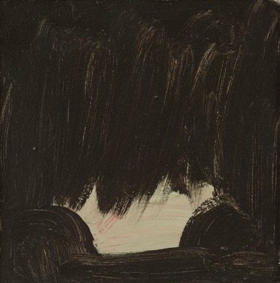
Lottie Consalvo, ‘From Here 6’, 2019, acrylic on board, 30 x 30 cm

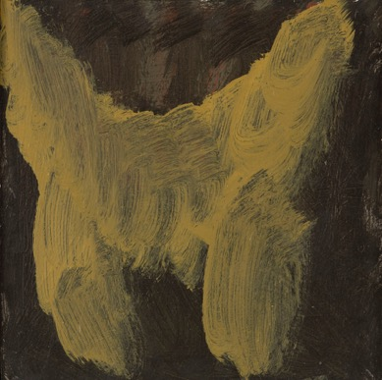

Lottie Consalvo, ‘From Here 7’, 2019, acrylic on board, 30 x 30 cm

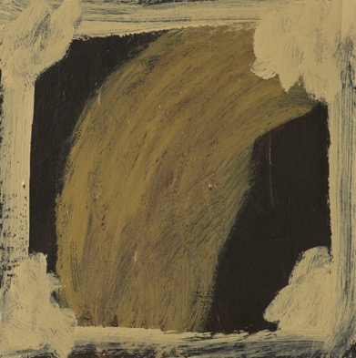

Lottie Consalvo, ‘From Here 8’, 2019, acrylic on board, 30 x 30 cm

Lottie Consalvo, ‘From Here 9’, 2019, acrylic on board, 30 x 30 cm

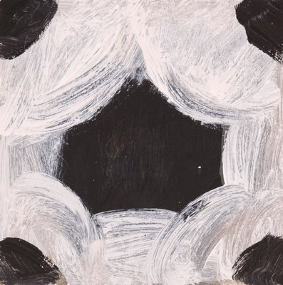

Lottie Consalvo, ‘From Here 10’, 2019, acrylic on board, 30 x 30 cm
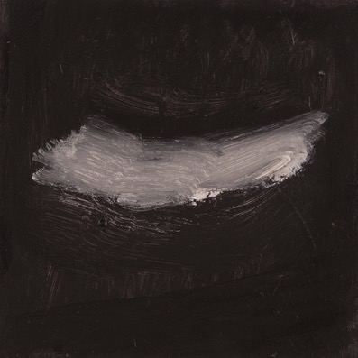

Lottie Consalvo, ‘From Here 11’, 2019, acrylic on board, 30 x 30 cm

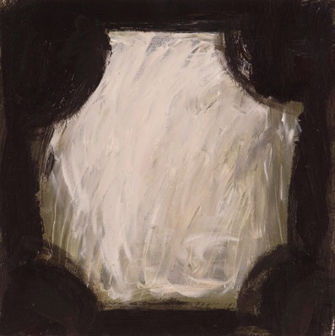

Lottie Consalvo, ‘From Here 12’, 2019, acrylic on board, 30 x 30 cm

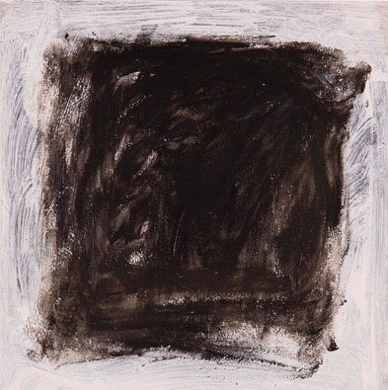

Lottie Consalvo, ‘From Here 13’, 2019, acrylic on board, 30 x 30 cm

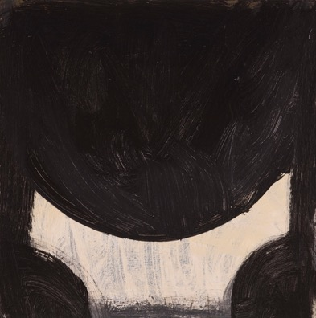

Lottie Consalvo, ‘From Here 14’, 2019, acrylic on board, 30 x 30 cm

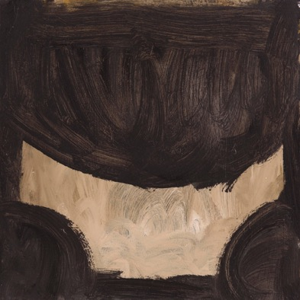

Lottie Consalvo, ‘From Here 15’, 2019, acrylic on board, 30 x 30 cm

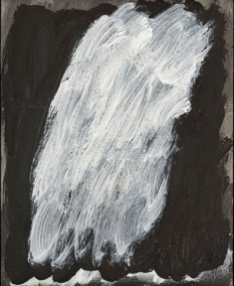

Lottie Consalvo, ‘In The Distance 7’, 2019, acrylic on board, 20 x 16 cm

Lottie Consalvo, ‘In The Distance 2’, 2019, acrylic on board, 20 x 16 cm

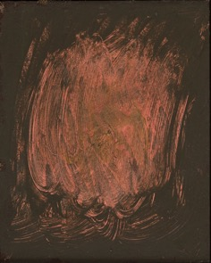

Lottie Consalvo, ‘In The Distance 3’, 2019, acrylic on board, 20 x 16 cm

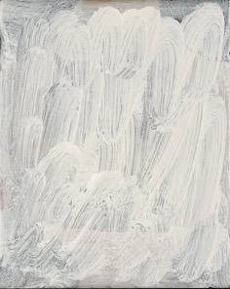

Lottie Consalvo, ‘In The Distance 4’, 2019, acrylic on board, 20 x 16 cm

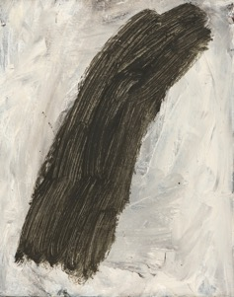

Lottie Consalvo, ‘In The Distance 6’, 2019, acrylic on board, 20 x 16 cm

LIAM GARSTANG

Sydney Contemporary NEXT program

Liam Garstang has been selected for the NEXT program, a new platform that showcases 50 works from artists under the age of 35, all priced under $5,000. This provides art lovers the opportunity to discover and acquire accessible work by the next generation of talent.

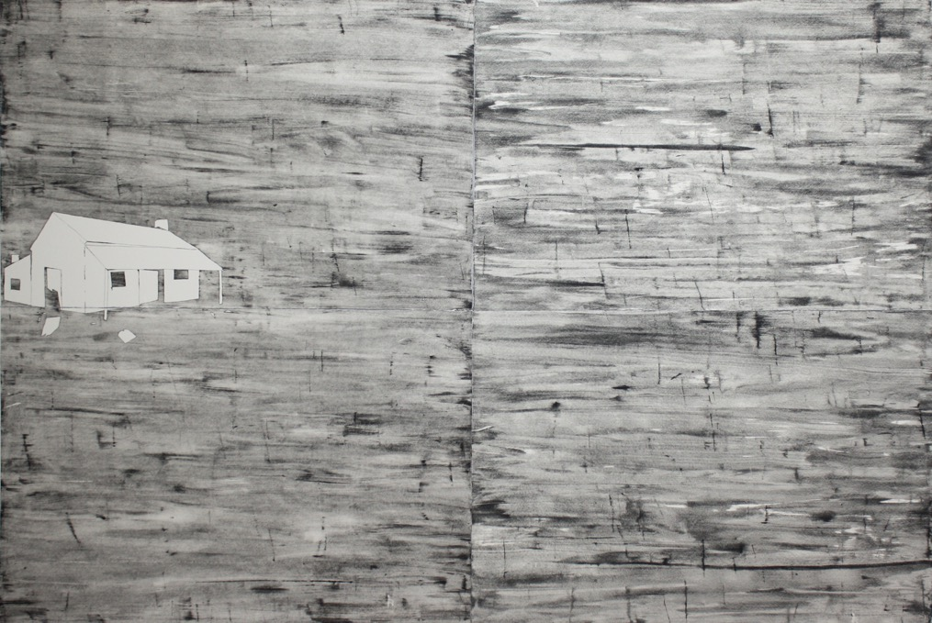

Liam Garstang, ‘The Ghost House’, 2018, drypoint on Hahnemuhle 300 gsmm paper, mounted on aluminium panel, 160 x 240 cm, edition of 3 + 1 AP

